Software Requirements Specification

Version 1.0

August 7, 2018

**Supermarket Automation Software**

Padmalaya Sahu

Priyabrata Mohapatra

Priyanka Behera

Submitted in partial fulfillment

Of the requirements of

CS 310 Software Engineering

**Table of Contents**

Table of Contents i

1.0. Introduction 1

1.1. Project Description 1

1.2. List of Actors 1

1.3. Scope of Projects 2

1.4. References 2

2.0. Overall Description 4

2.1 Functional Requirements 5

2.1.1 Use Case 5s

2.1.2 Entity Relationship Diagrams

2.1.3 Data Flow Diagrams

2.2 Non-Functional Requirements 15

2.2.1 System Requirements

2.2.2 Performance Requirements

2.2.3 Security Requirments

2.2.4 Database Requirments

2.2.5 Safety Requirments

Supermarket Automation Software

# INTRODUCTION

## 1.1 Project Description

The main aim of the software is to automate the bill and inventory system in a supermarket. It covers the functional and non -functional requirements of a supermarket.

Whenever any item is sold from the stock of the supermarket, this software prompts the employer to pass the information regarding the item to the transaction system. During the sales transaction, the name of the item, code number, quantity, price and item price are entered into the bill. The bill indicates the total amount payable. The inventory is then updated. It replaces the current manual processes of billing and inventory management in a supermarket.

1.2 List of Actors

* Owner
* Manager
* Cashier
* SalesPerson
* Customer

1.3 Scope of Project

The supermarket automation software consists of the following major functions:

* Maintaining and updating the inventory of the various commodities of the supermarket.
* Creating and printing sales transaction bills.
* Displaying and printing the sales statistics of various commodities for any particular period.

1.4 References

* Github

**2. Overall Description**

2.1Functional Requirements

2.1.1Use Case

#### Example :Search Article

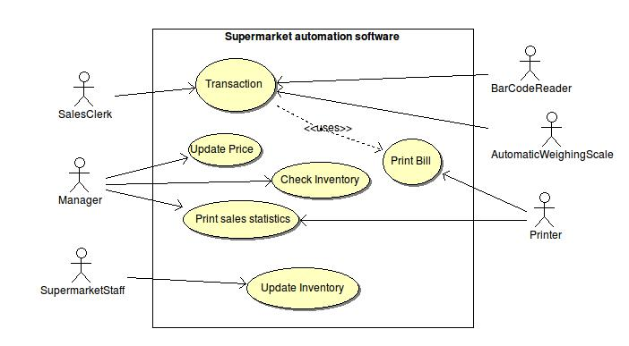

Brief Description

Whenever any customer purchases some items, the details of the items is passed to the cashier through the software and the bill is generated automatically and the inventory is updated simultaneously.

Initial Step-By-Step Description

Before this use case can be initiated, the Owner already has access to the stocks present in the Supermarket.

1. The customer purchases items according to his/her requirements and needs.
2. The details of the items is passed into the transaction system through the software
3. The system then generates the bill.
4. The inventory is updated .
5. The owner can have a check on the stocks and upgrade it accordingly.

2.1.2 Entity Relationship Diagrams

**Customer**

|  |  |  |
| --- | --- | --- |
| **Data Item** | **Type** | **Description** |
| Custome Name | Text | Name of item |
| Customer ID | Integer | Code of the item |
| Price /kg | Integer | Price/kg of the item |

**Items**

|  |  |  |
| --- | --- | --- |
| **Data Item** | **Type** | **Description** |
| Item Name | Text | Name of the item |
| Item ID | Integer | Id of the item |
| Unit Price | Integer | Price/KG of the item |
| Discount | Integer | Discount available |
| Quantity | Integer | Quantity purchased |
| Price/KG | Integer | Price/KG of the item |

**Owner**

|  |  |  |
| --- | --- | --- |
| **Data Item** | **Type** | **Description** |
| Owner Name | Text | Name of the Owner |
| Owner Item | Integer | ID of the Owner |

**Stock (for inventory updation)**

|  |  |  |
| --- | --- | --- |
| **Data Item** | **Type** | **Description** |
| Item Name | Text | Name of the Item |
| Owner ID | Integer | ID of the Item |
| Quantity Available | Integer | Quantity available of the item in the supermarket |

**2.2 Non Functional Requirements**

**2.2.1 System Requirements**

The system requirements for Supermarket Automation Software includes a processor with intel core to duo or above , a processor speed of above 2GHz, RAM of 1 GB or above, hard disk of 20GB or above.

**2.2.2 Performance Requirements**